**Unit 20**

**Assignment 1-Standard Compliance**

**Task 1:**

Mark-up languages are used define a piece will look on a webpage which is written as mark-up language known as “HTML”. HTML is used specify the format of text by using tags. E.g. <h1> heading one.

To change the style we use another language known as CSS which are cascading style sheets which has the responsibility of the style of a HTML document. Essentially it describes how things on a HTML should be displayed .For example, you have two heading tags: one is labelled “h1 and the other “h2”. Your client wants you to have a bold and white heading on h1 so it stands out to the user. However, he (client) wants h2 to be a smaller font size as the client wants it as a sub heading. Therefore, the CSS file will look like this:

**h1{**

**font-family: Arial;**

**color: #FFFFFF;**

**text-align: center;**

**font-size:65px;**

**font-weight: bold;**

**}**

**}**

**h2{**

**font-family: Arial;**

**color: #000000;**

**text-align: center;**

**font-size:45px;**

**font-weight: bold;**

**}**

CSS should always be used to style a HTML document because it makes a website interface more visually appealing to the end user. HTML files access CSS files by using a link tag which gets attained in the head of HTML document which looks like this:

**<link rel="stylesheet" href="/style.css">**

There are **3** types of CSS which are used to link to HTML.

* **Inline-** is when we use actually use the word style after the element that needs to be styled in the HTML document. So you only apply the style to the element by using “styles after in the element, in this case it is the H1 and P, after this you put the specific style you want which is the colour and alignment. Generally, inline is easy to use as you don’t need create a CSS file and keep on switching between the two which as a designer and as a developer you are saving time which is why as designer/developer I would prefer inline CSS.
* Here is an example below:

**<!DOCTYPE html>**

**<html>**

**<body>**

**<h1 style="color:blue;text-align:center;">This is a heading</h1>**

**<p style="color:red;">This is a paragraph.</p>**

**</body>**

**</html>**

Output:

**This is heading**

**This is a paragraph**

**Advantages of implementing inline CSS:**

* Less utilization of time-meaning that if there any errors with the code it can easily be solved as you have used “Style” on the chosen element which needs styling.
* Low HTTP requests- this enables the websites too load up much quicker which will keep the customer interested in going to the website rather than feeling annoyed with have to consume more time waiting.
* Simple to understand- this is easy to understand for developers because the style is attained in the same part of the element which is being styled.

**Disadvantages of implementing inline CSS:**

* **Needs to be used on each element-** it more time consuming for making large websites as you have to style each element. For example, if you want all headings to be aligned in the middle. You would have to put an inline <h1> </h1> in documents which would consume more times in download when users are trying to view the site.
* **Override of Internal/External-** inline is the most emphasized in cascade. This means you could over write additional style-sheets like internal and external accidentally which can lead to issues for the web developer.
* **Embedded-** is where you do CSS between the head tags. Therefore, the required page will use the CSS and any additional HTML tags. To actually use the CSS YOU USE A <Style> </style> and then the style which could be colour, size and fonts. Based on this all the CSS will be applied to the element. As web developer, I would pick this method because you do not need create a CSS file and keep on switching between the two, which as a designer and as a developer, you are saving time.
* **Here is an example below:**

**<style>**

**h1 {**

**colour: green;**

**margin-left: 40px;**

**}**

**</style>**

Output:

H1

**Advantages of implementing Embedded CSS:**

* The same style is allowed to be used on the same elements. So the developer won’t need to use the same HTML code for each asset. So for example if you have all the paragraphs the same you would need the same font which could be “Arial black.” Therefore, in the HTML document you will need to an inline tag “<p> which goes in internal file for the section.
* Embedded CSS is useful you can test your website without any damaging from the page you are testing.

**Disadvantages of implementing Embedded CSS:**

* Long loading time for the end user as there isn’t a lot of HTTP demands.
* High file size- this can increase as the developer which can cause a delay in loading when published online.
* **External**- is where the HTML is linked to the CSS using a link tag where the CSS will link to all the HTML pages. This link is put above the head tag in the HTML document. As a developer, I would pick this method because it is a more professional method and the webpage look more consistent as all the elements on each page will be linked with the same CSS.
* CSS link:

**<link rel="stylesheet" type="text/css" href="mystyle.css">**

**Advantages of implementing External CSS:**

* If you make a change to the CSS it will affect all the other linked pages
* The webpage looks far more consistent on multiple pages
* It has a better loading time as the CSS file is installed once and applied to the relevant HTML pages.

**Disadvantages of implementing External CSS:**

* To import a stylesheet can be frustrating, as you have to wait for it to be downloaded, which can be time consuming.
* You will have to carefully name each component in the HTML correctly for the CSS to be applied, which can be time consuming.

**Worldwide Web Consortium (W3C)**

The worldwide web consortium is an international organization where the staff of the company and even people from the public come together to carry out the development of web standards. Essentially, the role of W3C is to expand and broaden the growth of the web that could be the software, hardware and communication with the users globally and the compatibility of viewing webpages on smartphones, tablets etc.

**CSS Box model:**

The CSS box model is used for the design and layout of a HTML webpage. The CSS box model contains a margin, padding, border and content. By using the box model, the HTML elements on the webpage will certainly look presentable and a much more quality layout to the end user because it is a toolkit for the customization if elements. To do this you will have to carry out the four procedures in order to display the content.

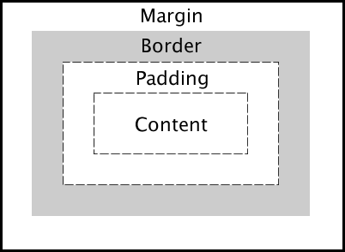

**Below is a brief description of the four procedures that make the CSS box model:**

* **Margin-** is transparent, displays the elements, and clears a space between the borders.
* **Border-** are sometimes used with colour or they are used with no colour. They are used to decorate webpages and make them look appealing.
* **Padding-** is the space between the content and the border. Same as the margin the padding is also transparent.
* **Content-** is the element that appears in the box, which could be text numbers or images etc.

Example of CSS box model on one of my websites:

HTML:

**<div class="column">**

**<img src="https://cdn.glitch.com/a4312852-36b0-438f-a76d-f53083ae0455%2Fh1.jpg?v=1570568732360">**

**<img src="https://cdn.glitch.com/a4312852-36b0-438f-a76d-f53083ae0455%2Fh2.jpg?v=1570568741647">**

**<img src="https://cdn.glitch.com/a4312852-36b0-438f-a76d-f53083ae0455%2Fh4.jpg?v=1570568750529">**

**<img src="https://cdn.glitch.com/a4312852-36b0-438f-a76d-f53083ae0455%2Fh3.jpg?v=1570568750779">**

**<img src="https://cdn.glitch.com/a4312852-36b0-438f-a76d-f53083ae0455%2Fh5.jpg?v=1570568750836">**

**</div>**

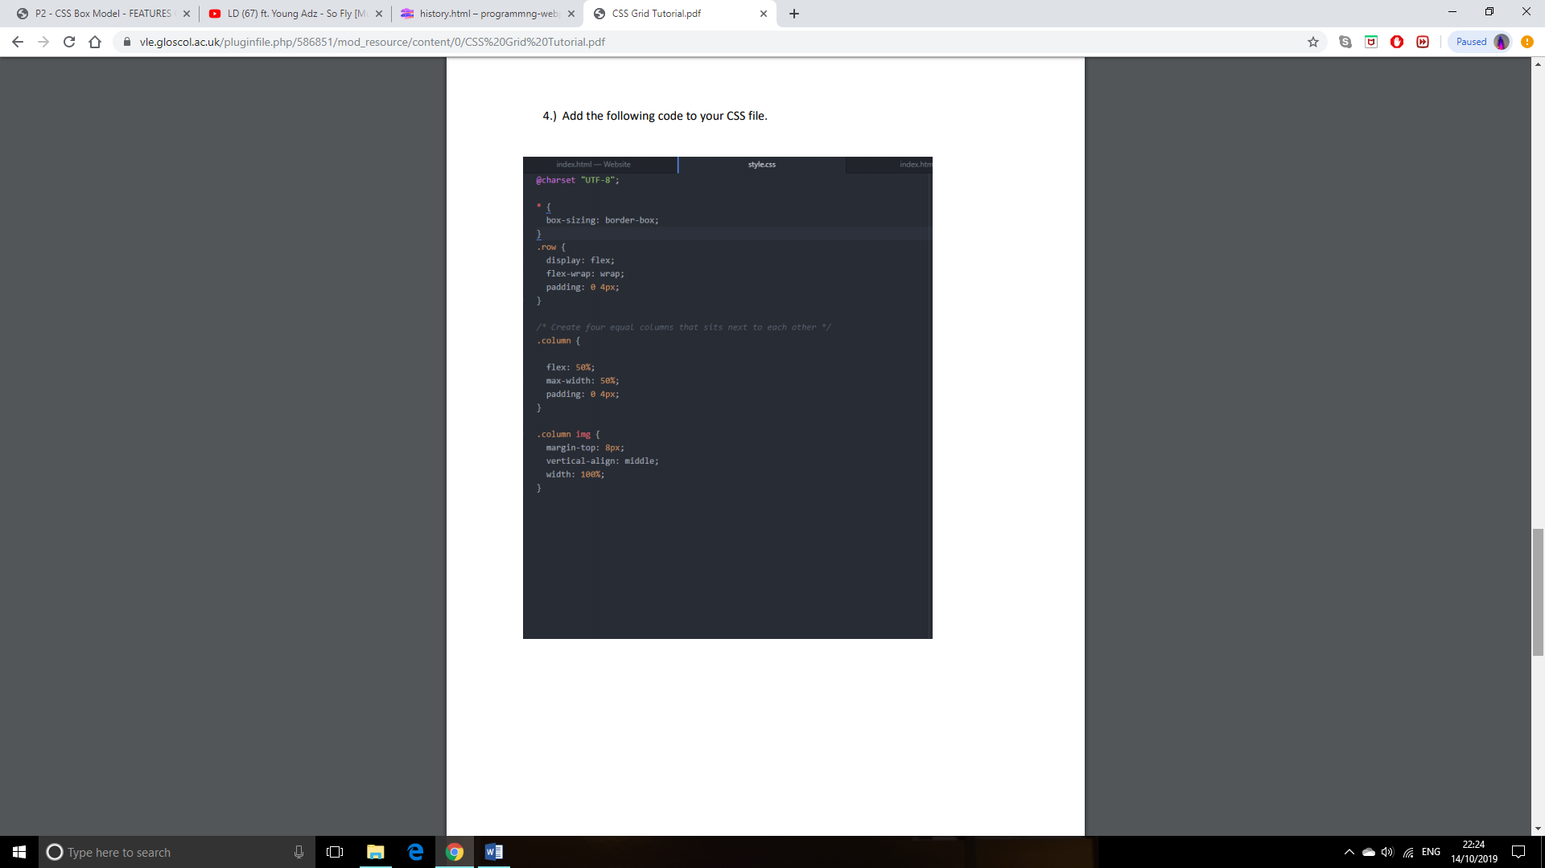CSS:

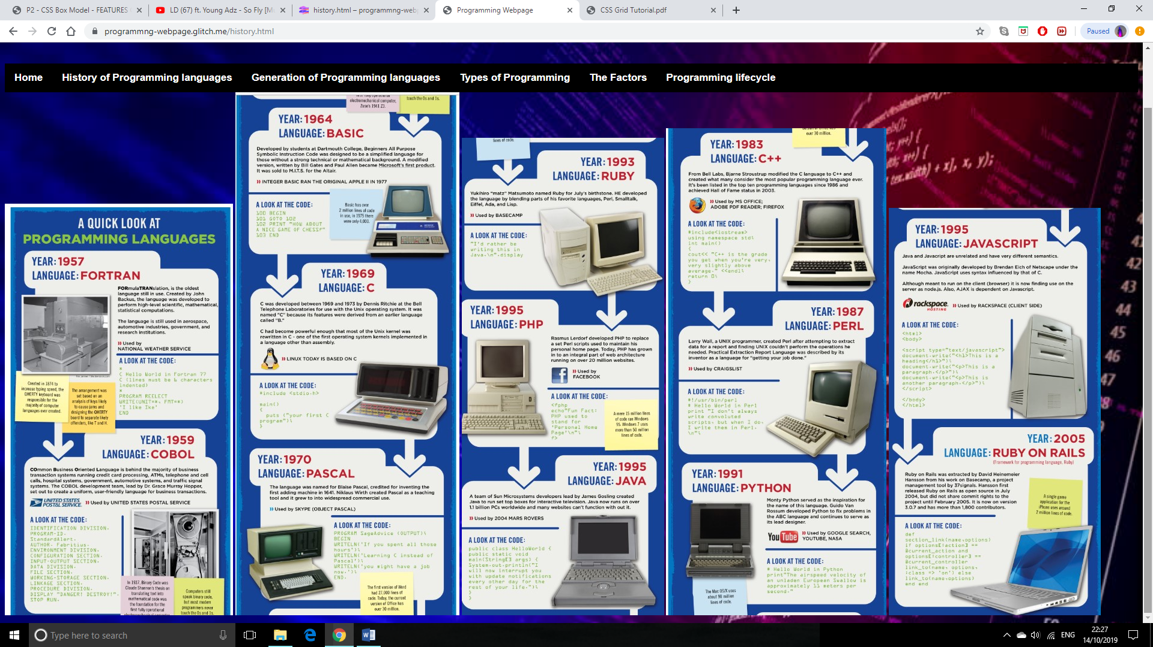

**Task 2:**

**The fundamental principles of how scripting languages work**

Scripting languages are programming languages that are combined with other programming languages, which are mainly HTML, Java and C++. For example, in a website HTML communicates with JavaScript to make the website more interactive and dynamic to the user. This is associated with client side scripting.

An example of a Scripting language is JavaScript which is a third generation high level language that was introduced in 1995 and is used the creation of web pages to carry out events also the behaviour of websites such as button clicking typing and hovering which appears on the web browser along with the

Scripting Languages are used in a HTML and they are inserted between the script tags located in the head of the HTML file. The page loads up in the code once has been simulated in the background, if the elements are above the scripting language if will be executed when all the elements have ran in the browser.

HTML and CSS.

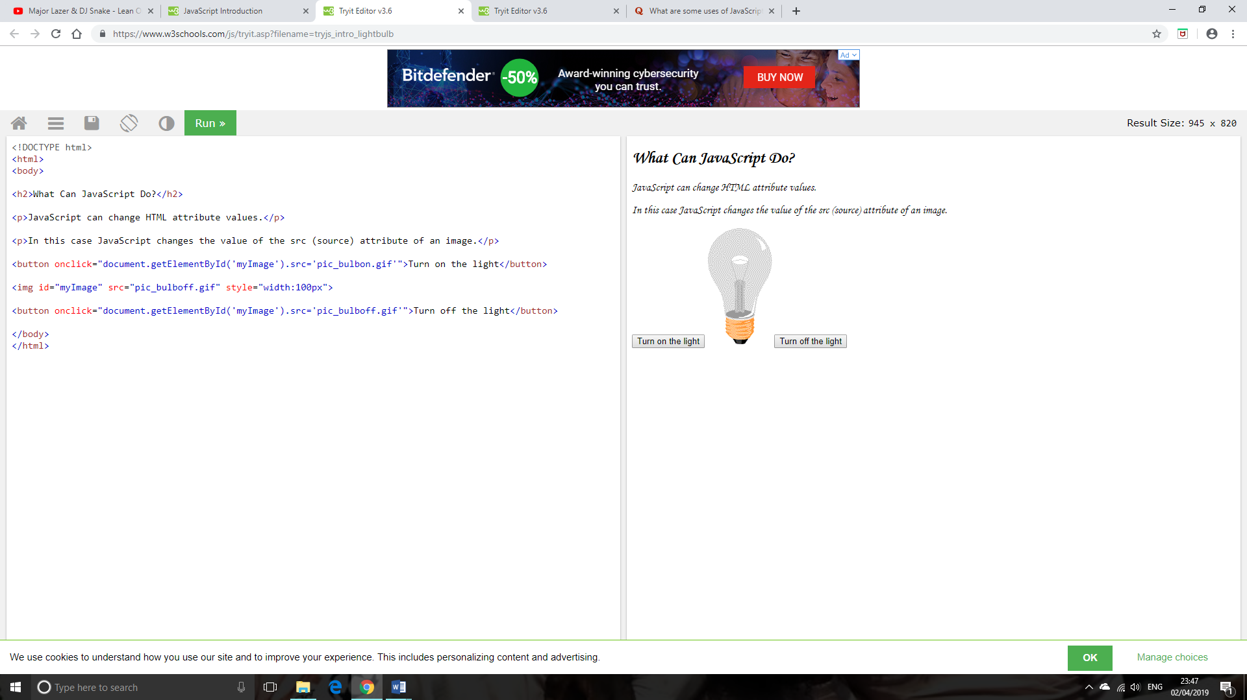**Example of code:**

When the user triggers the click event for “turn off the light” it will turn off.

When the user triggers the click event for “turn on the light” it will turn on.

**The fundamental principles are:**

* **Variables**- are multiple values of data that change when the end user is being asked something e.g. a question. The specific variable, which has been used, is stored in the memory location, which the variable associates with. In JavaScript, the word “Var” is used to assign a string (word) and an integer (number).

Example of code:

**<Script>**

**Var num=18**

**Var name=Sufyaan**

**Var sum=name+num**

**</script>**

* **JS security issues-** Java scripters produce submissions forms as hackers can type code that can simulate in the client side browser that can cause problems to the user’s PC especially the data that is stored on their PC.
* **Event Handler-** handles events such as click and hover events. As a result of this, the scripts become much more interactive and can carry out much more commands to perform events.

**Example of code:**

When the user triggers the click event for “turn on the light” it will turn on.

When the user triggers the click event for “turn off the light” it will turn off.

Event handler.

**How a scripting language (JavaScript) can improve functionality?**

Scripting languages are programming languages that are combined with other programming languages, which are mainly HTML, Java and C++. For example, in a website HTML communicates with JavaScript to make the website more interactive and dynamic to the user. This is associated with client side scripting.

Scripting languages can improve functionally through the user’s experience by using Java script. All users feel interactive with front-end side of webpages. JS can be used to improve the interfaces.

In terms of the adaptation of devices. When websites are loading on devices, JavaScript can be used. Therefore, the purpose for the devices of that site can be compatible for the platform in which the user is using the website so they can gain best previewing. For this reason, JavaScript can be used to make the content accessible and compatible on different screens sizes.

Analytics is another feature that can be improved functionally. This is where the report of web information is collected in order to improve websites. To improve this, analytics can be completed using JavaScript so it can track the conduct of websites through cookies and the developers can analyse information such as duration, number of visits on site and additional hyperlinks that we were visited.

Gadgets can be used to improve the function of scripting languages. This can be done by introducing a clock/calculator. This will improve functionally because the end user will be able to carry out calculations on websites that will make websites more efficient and a stable usage of the site.

**Explore how script solutions may be implemented differently in different browser JavaScript engines such as V8, Web Kit and Spider Monkey**

Script solutions can be differently in different JavaScript engines such as V8, Webkit and spdiermonkey. One reason can be the detection of browser that as all 3 browsers are different they will have differences in code as the strings will differentiate as it returns the name (bowser) which is running in the script.

The use of detection in the browser can interpret that features of JavaScript and see what the browser can cope with. For example, ancient browsers such as V6 will have old features and therefore, they will not support up to date features of JavaScript despite the fact that the website will still simulate in all browsers.